1. Project Title
SceneTrip: Movie-Based Trip Planner

2. Project Summary
Our project is a website that helps users plan a trip based on a movie. A user can search a movie they like, and the website will show real-world places that appear in the movie. Then the user can save these places into a trip plan.
We will use two datasets: one for movies and one for books. If a movie is adapted from a book, the website can also recommend the book to the user. We will use an AI API to help find the real places for a movie and show them in the app.

3. Creative Component
Our creative component is the AI feature. On the movie page, the user can click a button like “Find Real Places.” The system will call an AI API and get a list of real places related to the movie. Then the user can add any place into their trip.
This is creative because it helps users get useful information automatically instead of searching on their own.

4. Usefulness
This website is useful because many people want to visit places they saw in a movie, but it is hard to find the information quickly. Our website makes it simple: search a movie → see real places → save them into a trip.
Some websites already list filming locations, but they usually do not let users build and manage a trip. Our app is different because users can save places and organize them into a personal trip plan.

5. Realness
We will use real datasets to build this application, and we will use at least two different data sources.
Data Source 1: Movie dataset
- From: Kaggle

- URL: https://www.kaggle.com/datasets/thedevastator/san-francisco-filming-locations-1924-present

- Format: CSV
- Data size: 3414 rows, 12 columns
- What it includes: Index, Title, Release Year, Locations, Fun Facts, Production Company, Distributor, Director, Writer, Actor 1, Actor 2, Actor 3
Data Source 2: Book dataset
- From: Kaggle

- URL: https://www.kaggle.com/datasets/jealousleopard/goodreadsbooks

- Format: CSV
- Data size: 11127 rows, 12 columns
- What it includes: book title, author, and basic book information
6. Detailed Functionality

6.1 List of the functionality
- Smart Search and Trip Design: Users can insert their favorite movies into customers' dataset. Then we will search the locations where this movie was filmed in our movie dataset and create a new journey from these locations. In addition, if the movie is based on a book, we will output the book title and author to the users.
- AI-Powered Driven: we will extract real-world coordinates from users’ input film. Our AI api analyzes movie scenes to recommend real-world locations. Users can easily integrate movies into their physical travels.
6.2 Low-fidelity UI mockup
- 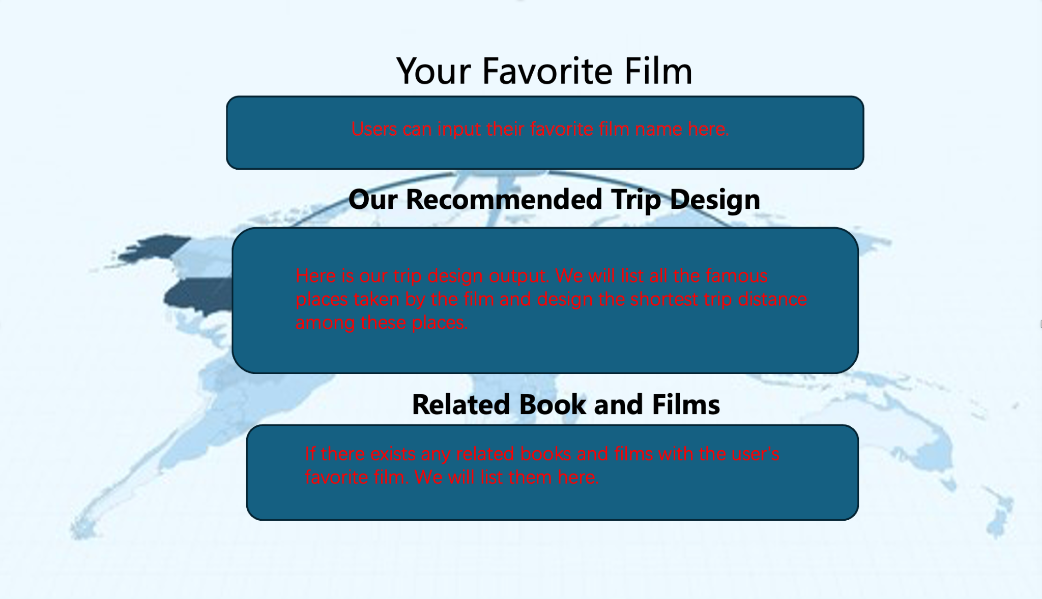
6.3 Project work distribution
- Member A (Frontend): build Search page, Movie page, Trips pages
- Member B (Backend): build database and APIs for movies, trips, and saved places
- Member C (AI API): connect AI API and show results on Movie page
- Member D (Books feature + testing): add the book section and help test the app

